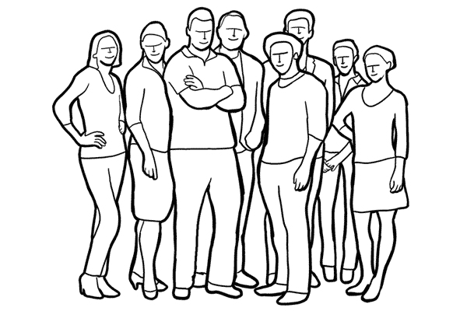
This is a group of friends who created a band. They need to wear outfits that they all might have in their closets, but still coordinate with each other. What is the theme between all of them? How do the design elements we learned affect what they are wearing?

