Quiz Review
*DO NOT WRITE ON THIS PACKET*
COPY DOWN THE QUESTIONS AS WELL AS YOUR ANSWERS SO THAT YOU CAN STUDY

- What are the three primaries of light? Is that additive or subtractive color?
- What is the most energetic color? The least energetic color?
- Name one of three colors that can be used on black fabric to prove if it is true black or not?
- What is the most important rule about handling stage lamps/bulbs?
- Gel is called gel because it used to be…
- An ERS is the only light that has?
- The three pronged plug we have in our houses in called?
- The type of plug we have here at school which twists is called?
- 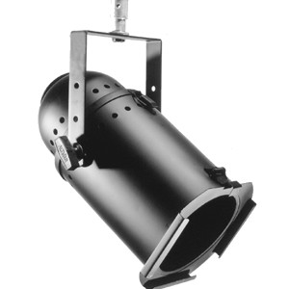What kind of light is this?
- Can all lights use gel? If not which ones can’t?
- List the three major companies of gel:
- Why was the Fresnel lens invented?
- Seasonal affectiveness disorder is a disease that causes what?
- 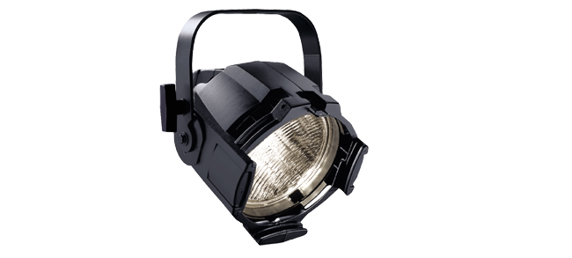What type of light is this?
- Which kind of bulb gets hotter, an LED or an incandescent?
- When hanging a light, after hooking the C-Clamp what is the next thing you MUST do?
- Name two different ways of hanging a fixture:
- What lighting positions normally use highly saturated color?
- What is a gobo?
- What are three problems with moving lights?

