Pop Quiz!
Name Date
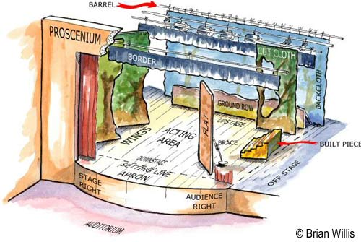
Please fill in the correct words in all of the blank spaces.

Part 2: Place an X on the correct square.
Actor
Audience
The actor above takes two steps stage left and then one step down stage. Where is he?

Actor
Audience
The actor above takes three steps up stage, one step stage right, five steps downstage and then four steps stage left. Where is he?

